**Latthe Education Society’s Polytechnic, Sangli**

Department of computer engineering

An

Micro project Report

Of

Sub**: Programming in Python**

Title:-**To detect objects using Colour Segmentation**

Submitted by

|  |  |  |
| --- | --- | --- |
| **ROLL NO** | **Enrollment no** | **STUDENT NAME** |
| 193319 | 1700430075 | Aditya Yogesh Gujar |
| 193320 | 17004300 | Servajeet Dagadu chavan |
| 193336 | 17004300 | Pratik Sachin Revanna |

2019-2020

**1.0 Rationale:**

OpenCV was started at Intel in 1999 by Gary Bradsky, and the first release came out in 2000. Vadim Pisarevsky joined Gary Bradsky to manage Intel's Russian software OpenCV team. In 2005, OpenCV was used on Stanley, the vehicle that won the 2005 DARPA Grand Challenge. Later, its active development continued under the support of Willow Garage with Gary Bradsky and Vadim Pisarevsky leading the project. OpenCV now supports a multitude of algorithms related to Computer Vision and Machine Learning and is expanding day by day.

**HSV** means Hue-Saturation-Value, where the Hue is the color.Saturation is the greyness, so that a Saturation value near 0 means it is dull or grey looking.And Value is the brightness of the pixel.(For a lot more info about **HSV** and other color spaces, go to HSL and **HSV** on Wikipedia) The python code is given below

The reason the early developers at **OpenCV** chose **BGR** color format is that back then **BGR** color format was popular among camera manufacturers and software providers. E.g. in Windows, when specifying color value using COLORREF they use the **BGR** format 0x00bbggrr. ... In other words, **BGR** is the horse's ass in **OpenCV**

In this project the object detecting has been implemented. If you want to detect any colourobject in a video then you can detect using this project

**2.0 Intended course outcome**

* Develop a python program to demonstrate the use of operators
* Perform operation on data structures in python

**3.0Literature Review:-**

* <https://docs.opencv.org/master/d0/de3/tutorial_py_intro.html>

From above mentioned website we learned about the CV2. OpenCV-Python makes use of **Numpy**, which is a highly optimized library for numerical operations with a MATLAB-style syntax. All the OpenCV array structures are converted to and from Numpy arrays. This also makes it easier to integrate with other libraries that use Numpy such as SciPy and Matplotlib.

* <https://stackoverflow.com/questions/10948589/choosing-the-correct-upper-and-lower-hsv-boundaries-for-color-detection-withcv/48367205#48367205>  
    
  from above mentioned website we understood about choosing the correct upper and lower HSV boundaries for colour detection

**5.0 Actual Methodology:**

import cv2  
import numpy as np  
  
cap = cv2.VideoCapture('take1.mpg')  
  
while(1):

# Take each frame  
 _, frame = cap.read()

# Convert BGR to HSV  
 hsv = cv2.cvtColor(frame, cv2.COLOR_BGR2HSV)

# define range of red color in HSV  
 lower_red = np.array([168,150,50]) #example value  
 upper_red = np.array([180,255,255])

# Threshold the HSV image to get only red colors  
 mask = cv2.inRange(hsv, lower_red, upper_red)

# Bitwise-AND mask and original image  
 res = cv2.bitwise_and(frame,frame, mask= mask)  
  
 cv2.imshow('frame',frame)  
 #cv2.imshow('mask',mask)  
 cv2.imshow('res',res)  
 k = cv2.waitKey(5) & 0xFF  
 if k == 27:  
 break  
  
cv2.destroyAllWindows()

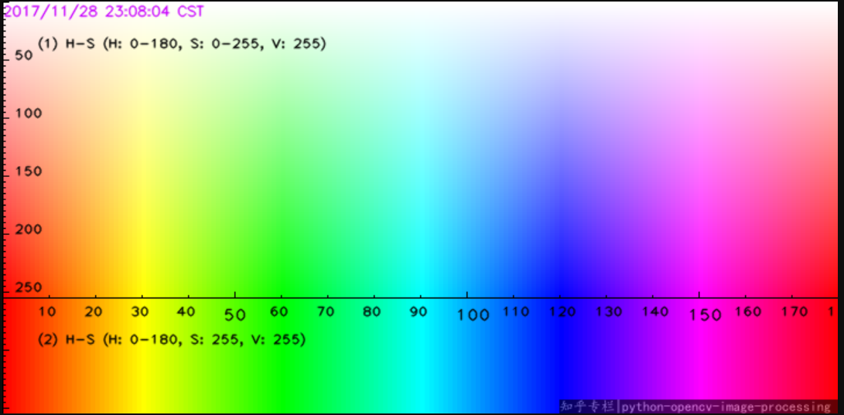

The x-axis represents Hue in [0,180), the y-axis1 represents Saturation in [0,255], the y-axis2 represents S = 255, while keep V = 255.

To find a color, usually just look up for the range of H and S, and set v in range(20, 255).

To find the Red color, we look up for the map, and find the best range: **H[168,180] and S[150,255], v[50,255]**

**6.0 Resources used**

|  |  |  |  |
| --- | --- | --- | --- |
| Sr.no | Name and resources used | Specifications | Remark |
| 1 | Operating system | Windows 8 | -- |
| 2 | Application Software | PyCharm 2018 | -- |
| 3 | Hard disc | 1 TB |  |
| 4 | Ram | 4GB |  |
| 5 | Processor | Intel core 2duo cpu 2.93 GHZ |  |

**7.0 Output**

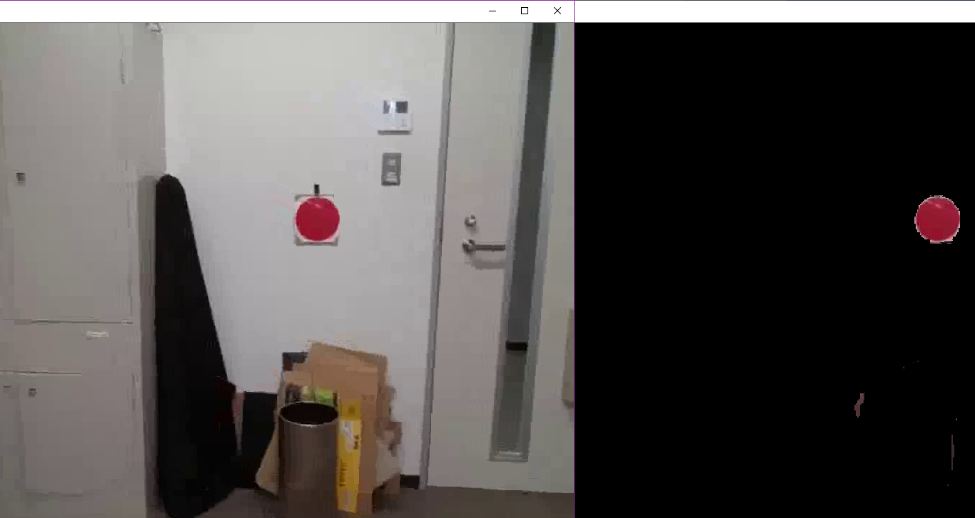

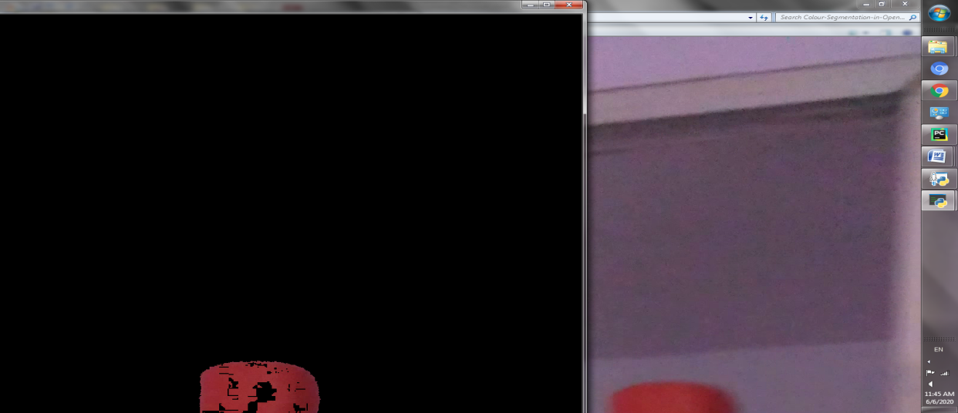

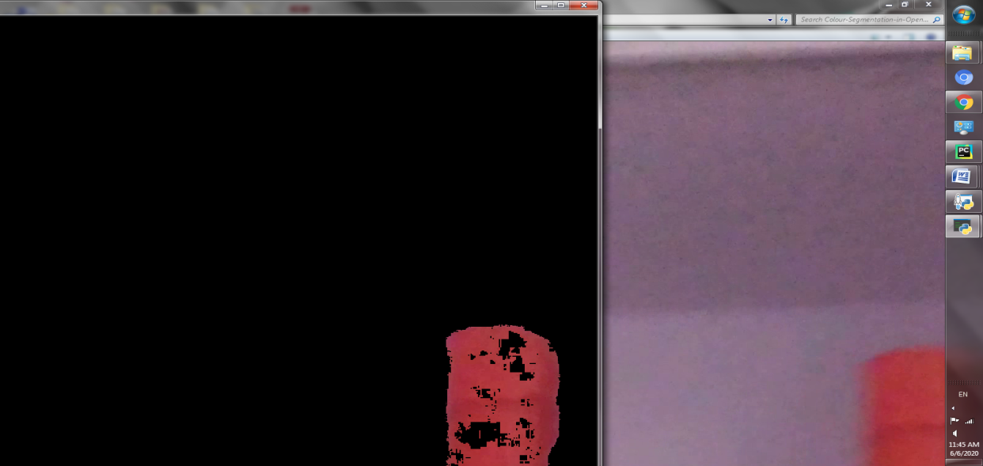

**8.0 Skill development:**

* Understood the knowledge about the openCV librarie
* Gained knowledge about the bitwise operators

**9.0 Future development:**

* Multiple objects will be detected in further updates